Hi, Phil Hewitt here – group arts editor at Sussex Newspapers (ie the Chichester Observer and its sister titles).
Congratulations on your book! Please tell me about it using this form.
Please type your answers into this Word document – and return it as a Word document. Please make your answers as chatty as possible – in the first person, as if you and I were talking. Please don’t use scary BLOCK CAPS!
Please send this form back to phil.hewitt@chiobserver.co.uk.
And please include a photograph. It needs to be a jpeg and at least 300 dpi, which means generally at least 200k. A pic of you, holding the book if you like – but not just the book cover.
Don’t worry about word length. I will try to fit in as much as possible in the newspaper, but there are no limitations as to what we can put online. We have a huge online audience which we are always looking to increase, so if I get your book online, it would be great if you could look out for it and share the link – maybe put the link on your own website. Online versions will go across all the West Sussex newspapers (a dozen or so). Across East and West Sussex, we have an online audience of more than a million. It is worth doing! But I would ask you to do your bit to increase our reach when we feature you.
Thank you – and best wishes for your book.
Phil Hewitt

Title of Book…….. The Kaleidoscopic Vision of Malcolm Lowry: Souls and Shamans

Who is it published by……. Lexington Books, Lanham, MD, USA.

Price and date of publication……… Kindle edition: from CDN$ 25.73 (£15.24) and hardcover from CDN$ 25.53 (£15.12); October, 2019.

Where can people buy the book…… Online at amazon.ca.

Your name and age….. Nigel Foxcroft, aged somewhat north of 21.

Where do you live (just town/village is fine)…. Angmering.

THE BOOK
Please tell me about the idea behind the book, its planning, its significance to you, its subject, why you feel the book will appeal to people.

Join me, Nigel Foxcroft on an odyssey across three continents in search of the souls of modern civilization
The Kaleidoscopic Vision of Malcolm Lowry: Souls and Shamans invites you to step into my world. It will take you on a highly topical journey into the life and works of the English late modernist writer, Malcolm Lowry. Born in New Brighton, Wirral, this great fiction author had close links to Sussex. Writing in the first half of the twentieth century, he was fascinated by the complex and interrelated realm of his experiences: it was – and is -one where ancient and contemporary cultures meet. Join me on an expedition which spans the continents of Europe, the Americas, and Asia. We shall trace Lowry’s steps by venturing to Russia, Mexico, Canada, and the Far East on a quest to decipher the hidden secrets of cultures and civilizations. My interdisciplinary book will provide you with a historical lens which highlights literature’s role in heightening awareness of contemporary issues of global significance too. These include current economic and political uncertainties, environmental concerns, and ecological degradation. I hope readers will share a glimpse into Lowry’s colourful, yet often disturbing works, whilst being prompted to see some of our own society’s challenges from a different perspective.
The publication of The Kaleidoscopic Vision of Malcolm Lowry brings to fruition an odyssey on which I embarked – somewhat unexpectedly - seventeen years ago. I was inspired by Dr Alistair Davies - my former tutor at the University of Sussex - who introduced me to Lowry’s masterpiece, Under the Volcano. Set in Mexico on the Day of the Dead in November 1939, it cinematically flashes back to events happening in 1938, before the outbreak of the Second World War. Conjuring up the Consul’s recollections of his childhood and adolescence in Wirral, Liverpool, and Cambridge, it then spins forward to his dreamt of prospects in British Columbia, Canada….
Intrigued by the bright, dazzling skull on the cover of my copy of Under the Volcano – and stimulated by reading this amazingly complex novel - I set off on a parallel journey. It took me to Mexico City (where I witnessed the opening scenes of the James Bond film, Spectre being filmed in 2014) and on to Quauhnahuac - modern-day Cuernavaca - for the Día de Muertos. Mesmerized by the interconnectedness of various cultures, I delved back into the pages of Under the Volcano to assess the authenticity of the living souls depicted and to fathom out how Lowry laments the loss of indigenous cultures by linking the past, present, and future contexts of Mexican, Hispanic, and Russian civilizations. I found particularly appealing his insight into human nature derived from his pursuit of an elixir of life for the survival of humanity on the brink of catastrophe. His long-lost work of the 1930’s, In Ballast to the White Sea immersed me in a world afflicted by economic depression and political polarization and vacillating between fascism and communism….

Please tell me how you came to write it; what inspired you; who you are aiming the book at; how you enjoyed the writing; and please outline the starting point for the book.
As if in a dream, my vocation had beckoned me to travel to the weird and wonderful country of Mexico to appraise its exotic treasures and to gather materials for my book-project. Having been kindly funded by Santander and the University of Brighton, I delivered an invited keynote lecture on Lowry’s East-West connections at the Museo de la Casona Spencer in Cuernavaca on that very Day of the Dead, 2nd November. A short field-trip to Oaxaca – the land of the Zapotecs - enabled me to follow in his footsteps by visiting the archaeological sites of Mitla and Monte Albán (“White Mountain”), dating back to 900 BC and 500 BC, respectively.
An excursion to the National Museum of Anthropology in Mexico City reminded me of one I had taken to the Aztecs exhibition at the Royal Academy of Arts in London in 2003. Shocked by the desecration of that civilization by the Spanish conquistador, Hernan Cortez in his 1519-21 conquest of Mexico, I realized that the Día de Muertos commemorates the preciousness of life and cultural heritage. I discovered that this fiesta originates from 2 500-year-old shamanic rituals which were cherished by the Aztecs and then fused with Hispanic influences. Conceived as a means of bringing the spirits of the fallen back from the Underworld, if only for a day, it combines historical traditions with visually stunning modern interpretations. These comprise displays of dazzling masks, processions of exotic costumes, and reverberating folk recitals of regional Mexican Spanish music performed by local mariachi bands….
An ideal starting-point for penetrating the workings of Lowry’s mind is his enchanting novella, “The Forest Path to the Spring” in The Voyage That Never Ends. Its beautifully woven, poetic narrative transported me to the banks of the Burrard Inlet in Dollarton, North Vancouver. On the way to draw water from a spring, I was confronted by a cougar (or mountain lion). A figment too of Lowry’s imagination, its glimpse evoked memories of his past – a wormhole to resolve childhood anxieties….
I discovered that another clue to his kaleidoscopic perceptions of the universe lies closer to home, in Sussex. The gorgeous gardens surrounding West Dean House enable us to appreciate his fascination with the natural environment. They remind us of Edward James’s establishment of the impressive complex of Las Pozas (The Pools) near the village of Xilitla in Mexico’s subtropical mountainous rainforest in 1945. My interest in surrealism was nurtured too by a visit to Farleys House and Gallery (originally known as Farley Farm House) near Chiddingly. It was the home of the painter and co-founder of London’s Institute of Contemporary Arts (ICA), Sir Roland Penrose and of his American wife, the photographer Lee Miller. Decorated in a surrealist style, its paintings and artefacts on show are mostly of that genre. But I discerned that it was actually Jeake’s Storehouse - founded in 1689 on Mermaid Street in Rye - which was the focal point for Malcolm Lowry’s web of Sussex connections. In 1924-47 it was leased to his mentor, the American symbolist poet and novelist, Conrad Aiken, who introduced him to the surrealist artists, Paul Nash and Edward Burra. Having resided in Mexico, USA, and Canada, it was to Sussex that Lowry would return in 1956 to lodge at The White Cottage in Ripe….

Is it a stand-alone publication or will there be sequels?
I have a long-term interest in languages and cultures. I learnt French and Russian at school. I read English literature, history, and Russian Studies at university and taught myself Hungarian. I have lectured these subjects – and EFL - at institutions of higher education in Hungary and the UK. My research aspires to contribute to the development of a framework for investigating the international dimensions of modernism. It seeks to lay a firm foundation for analyzing the influence of cultures and civilizations on modernist authors and avant-garde artists.
Sequels include the following chapters in these forthcoming monographs:
‘In Ballast to the White Sea: The Springboard for Russian Influences on Malcolm Lowry’s Visionary Intellect’. In Helen Tookey & Bryan Biggs (eds), Remaking the Voyage: New Essays on Malcolm Lowry and ‘In Ballast to the White Sea’ (Liverpool: Liverpool University Press, July 2020);
‘West-East Influences on Malcolm Lowry.’ In Marcelo Teixeira (ed), Actas do XIV Encontro Internacional Malcolm Lowry (Lisbon: Banco de Portugal, July 2020), 59-77.

YOU
Are you a first time author? If not please tell me a little about your other books?
This is my first full-length book and the fulfilment of a longstanding ambition of mine. I have written extensively - in English and Russian - for peer-reviewed academic journals, newspapers, and other publications. My research areas extend from modern Anglo-American literature (J. M. Coetzee, Malcolm Lowry, and Toni Morrison) to Russian Literature (A. S. Pushkin, M. Yu. Lermontov, and Anton Chekhov) and Russian historical linguistics.
I have been invited to deliver keynotes and papers at various intercontinental conferences. These activities have enabled me to develop a global research network stretching from Mexico to Canada, USA, France, Portugal, and Japan. I am also keen on investigating our local modernist heritage. I have developed links with the Sussex Modernism Project led by Dr Hope Wolf at the Centre for Modernist Studies at the University of Sussex, Towner art gallery in Eastbourne, and Bluecoat (Liverpool's centre for the contemporary arts).

When did you start writing and why?
My very first academic articles were published in the 1980s. I was motivated by an interest in European languages, cultures, and civilizations.

Are you doing any book events?
I relish the opportunity to launch my book by delivering Powerpoint-illustrated talks at arts festivals and other cultural and literary events as we emerge from the Covid-19 lockdown!

For more information, please contact: Nigel H. Foxcroft, Senior Lecturer in English Literature, Russian and European Studies, School of Humanities (Falmer), University of Brighton.
E-mail: N.H.Foxcroft@brighton.ac.uk.
Research site: <https://research.brighton.ac.uk/en/persons/nigel-foxcroft>

DON’T FORGET THE PHOTOGRAPH!
Thank you and good luck with sales!

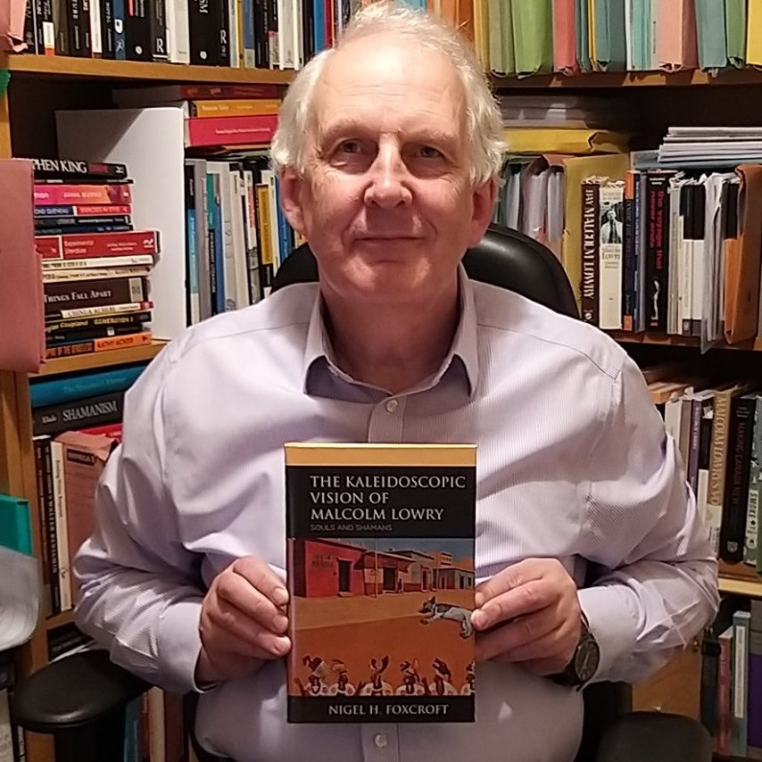
Photo: © Georgie Foxcroft

Nigel H. Foxcroft, 24th June, 2020

ENDS

